Cape Cod Beauty of Light
September 9-11, 2022

REGISTRATION FORM

Name _________________________________________________________

Address ________________________________________________________

Phone __________________ Email _________________________________

COST: $175.00
This price includes participation in three days of plain air painting, reception and sale on Saturday evening at the Hyannis Yacht Club, maps, various materials, directions and resources for each day.

The deadline for registration is August 15, 2022.
Be sure to sign up early as space is limited.

Friday, September 9, 2022, 12-3 pm. Cape Cod Art Center: Registration and check in to get your paper or canvas stamped. Stamps received on this date are good for both days.

Saturday, September 10, 2022. 9-10 pm. Hyannis Yacht Club: Registration and check in to get your paper or canvas stamped.

Sunday, September 11, 2022. Paint the sunrise for fun at the Hyannis Yacht Club. Stay for coffee.

Paint at locations of your choice and return your framed and ready to hang artwork to the Hyannis Yacht Club by 2 p.m. on Saturday, September 10. All work must be painted on location.

Cash Prizes: Juried awards will be announced.
5:00 – 8:00 PM Reception at the Hyannis Yacht Club

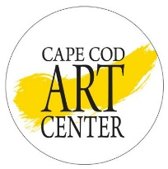
Cape Cod Art Center
3480 Route 6A, P. O. Box 85, Barnstable, MA 02630
508-362-2909 ~ CapeCodArtCenter.org

